COMP3111 Milestone 3 Report

**Topic : HKUST Freshmen Chatbot**

Team Members : Chan Yee San Samuel, Leung Cheuk Nam, Liu Yan Ho, Fung Yuk Cheung, Lai Yui Fung

**Part 1**. URL to bitbucket repository containing source code

<https://bitbucket.org/projectgroup18/ust-freshmen-chatbot>

**Part 2**. UML Class Diagram and Sequence Diagram of Project

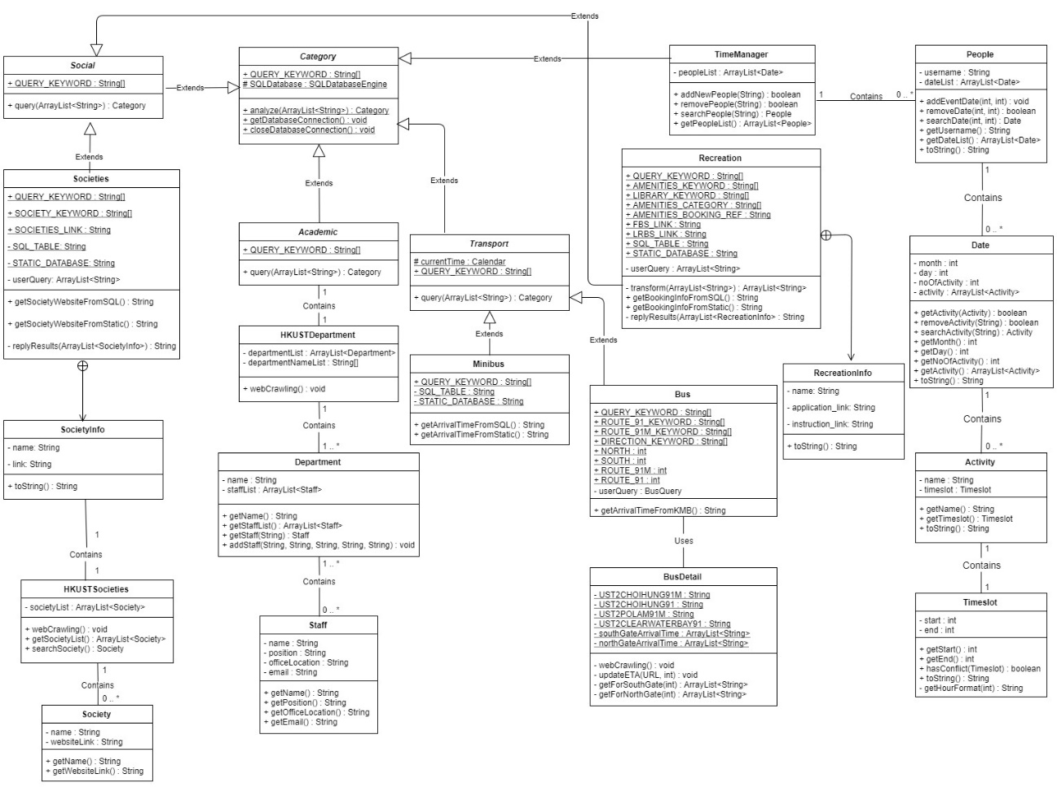

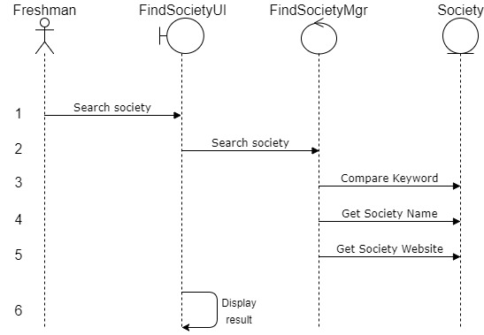

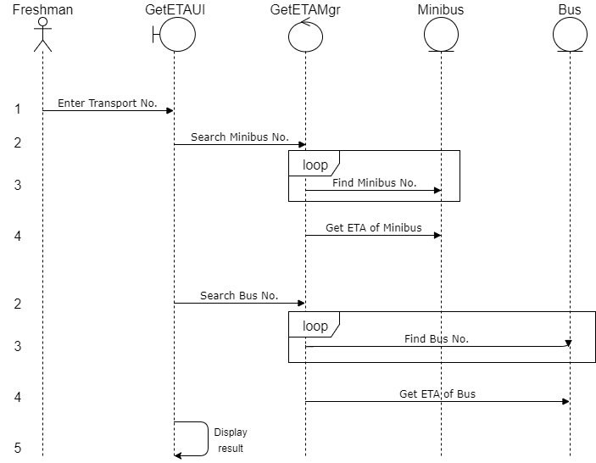

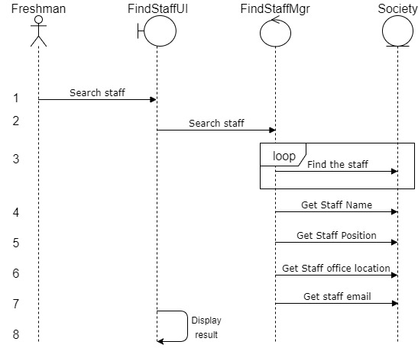

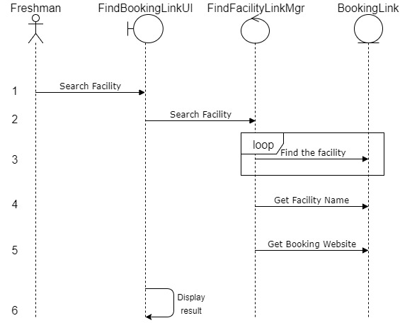

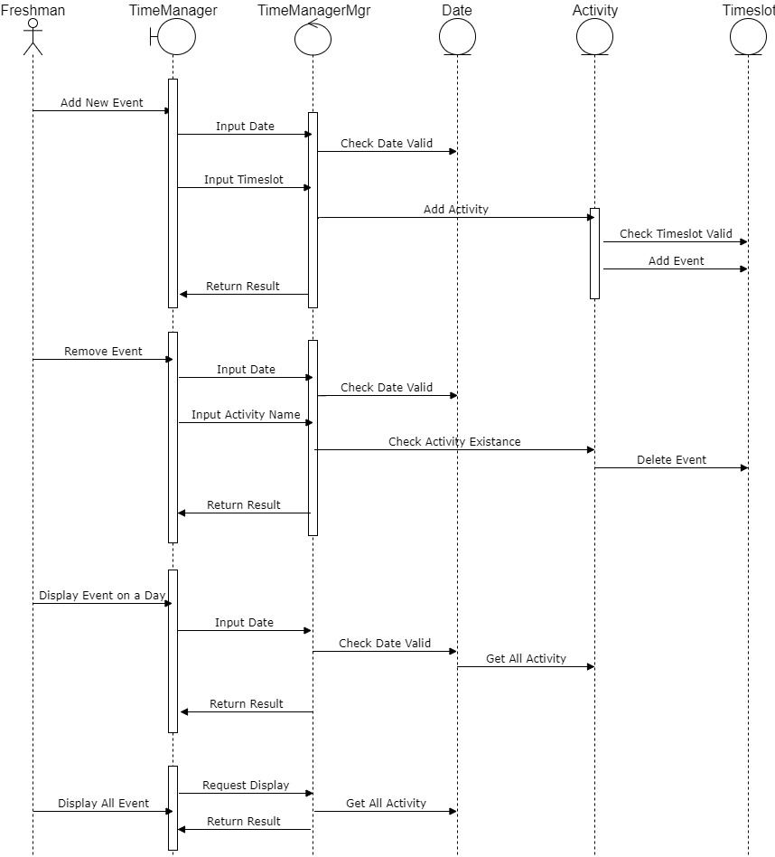

**Part 3**. QR Code of LINE chatbot



**Part 4**. Details on testing

**Part 5**. URL of Javadoc on project

**Part 6.** Screen cap of project management tool

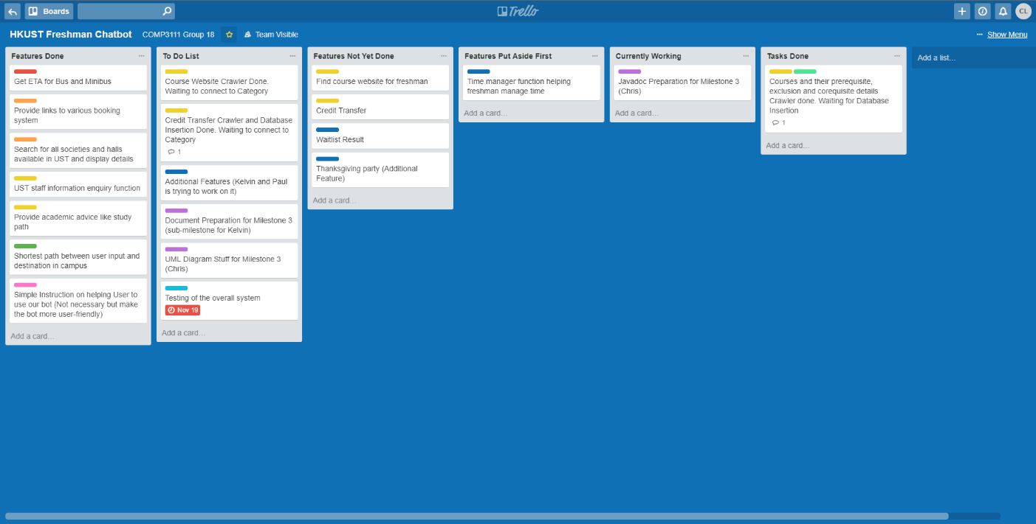

Make features as milestones and pin them on board to remind teammates.

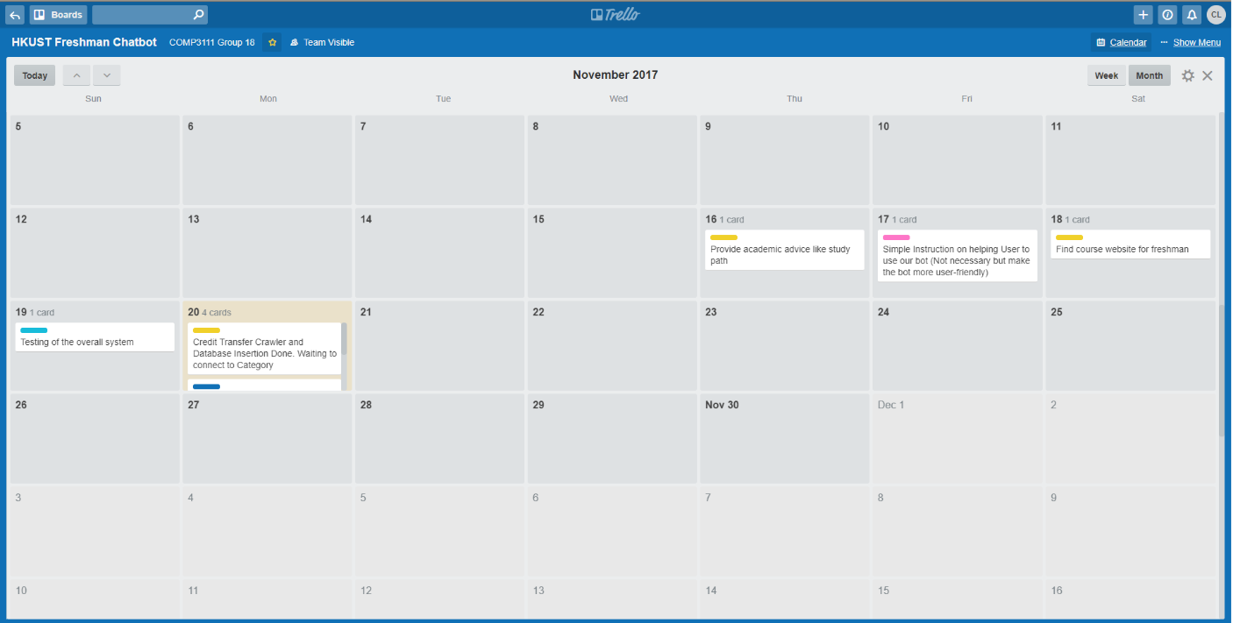

Make use of Calendar to view the deadlines more clearly.

**Part 7.** Table of features approved in Milestone 1 and corresponding progress

|  |  |  |  |  |
| --- | --- | --- | --- | --- |
| Features | Is Completed? (Y/N) | Sample Test Cases (if completed) | Expected Result | Checked (by TA) |
| Feature 1 – Return ETA for the shortest path between user input and destination in campus | Y | Input “Can I know eta from 4619 to 2407?” | Return “It takes 1 mins and 54 seconds to go from 4619 to 2407” |  |
|  |  | Input “Can I know eta from LTA back entrance to 2504?” | Return “It takes 0 mins and 53 seconds to go from LTA back entrance to 2504” |  |
|  |  | Input “Can I know eta from 4619?” | Return error message which remind user they have ambiguous query |  |
| Feature 2 – Find course  website for freshman | Y | Input “Can you find the course website of COMP 3111 for me?” | Return the title and website link of first 4 most relevant course website upon query |  |
|  |  | Input “Can you find details of course COMP 4641 for me?” | Return the title and website link of first 4 most relevant course website upon query |  |
|  |  | Input “Can you find 2012?” | Return error message which remind user they have ambiguous query |  |
| Feature 3 – Provide academic advice for freshman like study path | Y | Input “Can you suggest some course after I have taken COMP 2012?” | Wait for input |  |
|  |  | Input “What can I study if I have finished COMP 3111?” | Wait for input |  |
|  |  | Input “Suggest some path for me after COMP3511” | Wait for input |  |
| Feature 4 – Time manager function to help freshman plan their schedule wisely | N |  |  |  |
| Feature 5 – Provide links to various booking system of campus facilities to freshman | Y | Input “Where could I book music room in UST?” | Return corresponding link successfully |  |
|  |  | Input “Where to book Lecture Room and also Study Room?” (No lecture room keyword in database) | Return corresponding replacement for suitable room booking link |  |
| Feature 6 – Get ETA for bus and minibus that available in campus like 91, 91M and 11 | Y | Input “ETA of 91 at south gate” | Return the ETA of bus route 91 successfully |  |
|  |  | Input “ETA of minibus 11 please ?” | Return the ETA of minibus route 11 successfully |  |
|  |  | Input “Can I know eta of 91m at north gate?” (Test at night which the last bus has gone) | Return the Chinese representation of “the last bus has gone” |  |
| Feature 7 – Search for all societies available in UST, displaying name and website to freshman | Y | Input “Where is the webpage of film society?” | Return webpage link of film society |  |
|  |  | Input “Nature club, Cricket club, where could I get info on them?” | Return webpage link of nature club and cricket club |  |
|  |  | Input “Where could I get info on HKUST soc?” | Return the webpage which contains all details of UST societies |  |
| Feature 8 – UST staff information enquiry function for freshman,  Provide office location etc | Y | Input “Could you tell me where the office of Prof. Li Bo is?” | Return details of Prof. Li Bo |  |
|  |  | Input “Where is the office of professor Li?” | Return details of all professors with surname Li |  |
|  |  | Input “Where is the office of Sunghun Kim?” | Return details of Prof. Kim |  |
| Feature 9 – Login freshman SIS and get waitlist result if any | N | N/A | N/A | N/A |
| Feature 10 – Get freshman input and check if their course can apply credit transfer | N | N/A | N/A | N/A |